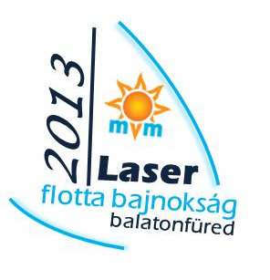
MVM HUNGARIAN LASER FLEET CHAMPIONSHIP AND INTERNATIONAL REGATTA 2013 - BALATONFÜRED, KOLOSKA MARINA, 15-17/06/2013
To be filled in by the Organizing Authority!
Enrty fee payment:
Entry/registration succesful:

ENTRY FORM

Club

 | Class | Age Group | Name | Date of Birth | ISAF Number | Sail Number | Comment
1.
2.
3.
4.
5.
6.
7.
8.
9.
10.
I accept that neither the organizer nor its representatives shall bear any responsibility for any loss, damage, or personal injury howsoever caused to boat or skipper. I certify that I bear full responsibility for my participation on the ashore and off shore events of the regatta as well. I accept that any inspection of the sailing licence, medical documents, boat insurance and of compliance with the security standards serve fair play racing. I further accept and agree to be bound by all the provisions of the notice of race and the racing rules of sailing that govern this race on behalf of myself as well as on behalf of the members of the crew .

Undersigned, the coach of the team, authorised by the competitors, I agree to be bound by the above mentioned provisions on their behalf : ________________________________________
Name of the rescue boat: ______________________________________________________________ Signature
Name of the rescue boat driverr:________________________________________________________

